u6-u7 dribbling session
Category: Technical: Ball Control
Difficulty: Beginner
Warm up
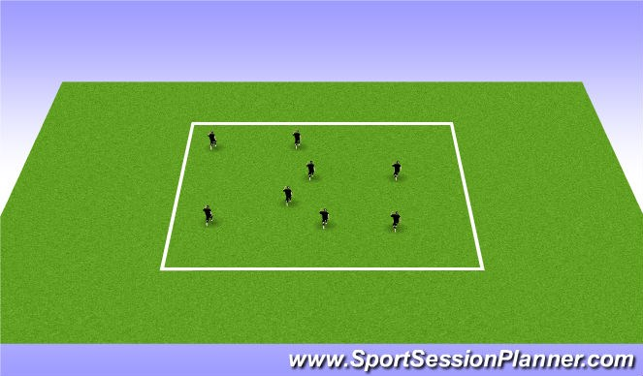
6 players running through out the field doing different movements.
Shuffling, skipping, sprinting, small steps etc. Games to play:
Freeze tag- two players start as taggers, when a player who is NOT a tagger must freeze and the only way they can move again is if a teammate goes under/between their feet.

Cone tag- Half the team with a cone the other half without a cone games go for 1-1:30min trying to tag the others with a cone, once a player who is tagged with a cone the player than takes the cone and tries to tag someone who does not have a cone
controlled cone dribble
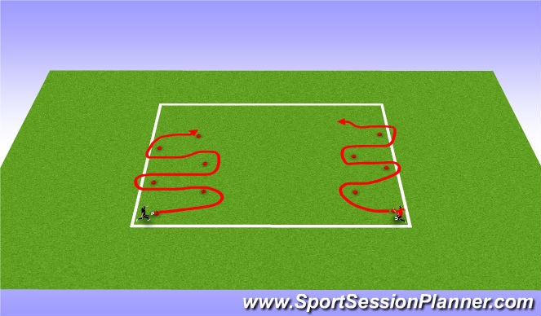
Players dribble through cones concentrating on keeping control of the ball.
Different types of dribbles can be: outside of foot (sweep)
Inside of foot (chop) Ball drag back around cone CP:
Controlled Dribble
Head Up
Allow players to gain confidence with the ball.

This Exercise can be done in free space as well (allow for creativity)
Dribbling to get away from defender
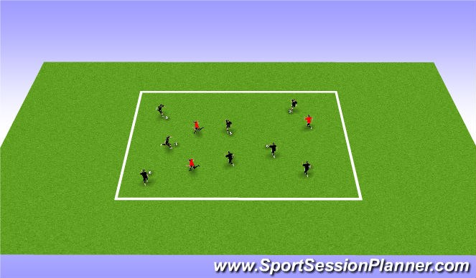
dribbling to get away from defenders.
CP: Dribble with head up, control the ball with small touches. Players who starting as defenders should try and steal to keep the ball

The object is to keep the ball and get away from the defender. Once the defender wins the ball the player who loses the ball must go and try to get a ball from another player.

1v1 to goal
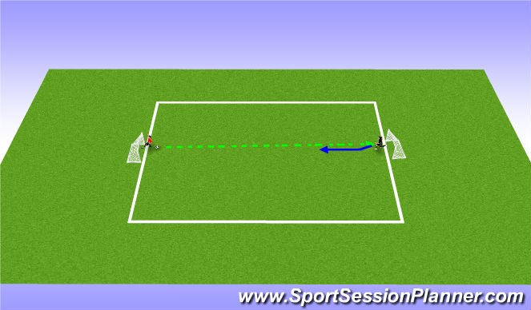
Player becomes defender off of a pass.
The receiving players should dribble to go with pace, but keep the ball under controll.
encourage the player to use different parts of his/her foot.
look for the players to use laces to dribble and change his or her pace.
2v2 to goal
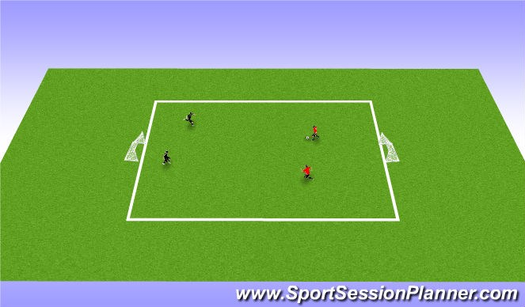
2v2 dribbling game players must take two touches on the ball and the team should try to complete Three passes before scoring.This will help the player keep the ball and be confident to attack the goal.

