Basic Defending  Category: Technical: Defensive skills  Difficulty: Beginner | Barrington Area Soccer Association
free space dribbling (10 mins)
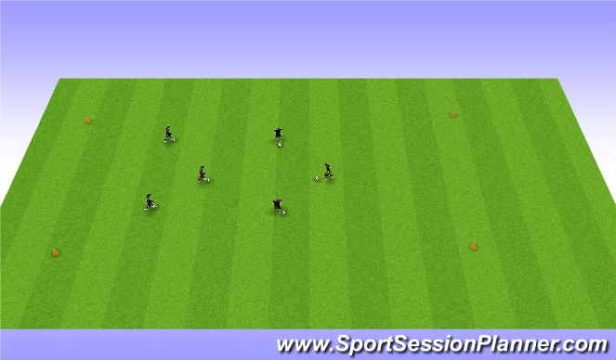
Coaches cone off a dribbling area require players to practice moves. Scissors step over pull back turn kryuff
part 1 mving feet for defending (15 mins)
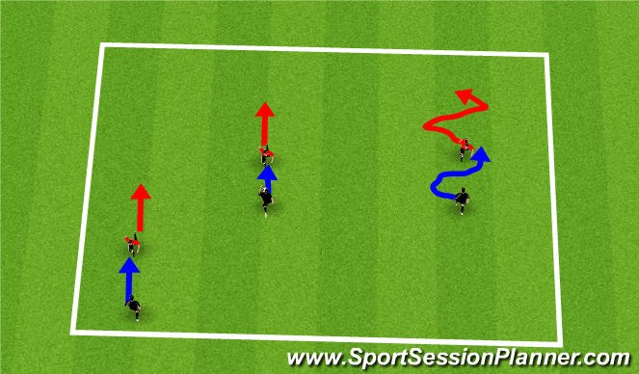
Players work with a partner.
Player in red is the defender they are working on moving and keeping the dribbler in front of them
as the player in black dribbles the Red player should keep an
"arms length away" from the dribbler
Defender should be on balls of feet and shift feet
defending in game like (15 mins)
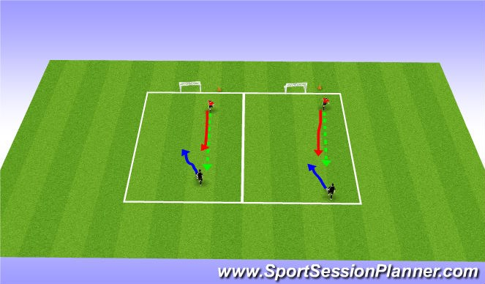
Players play 1v1 to goal keeping the ball close to eachother. The defender closes gap to keep the ball close and in front of them attacking player is trying to score on goal behind.
Defender is trying to win the ball and take it to the endline for a point.

1v1 2v2 to goals (20 mins)
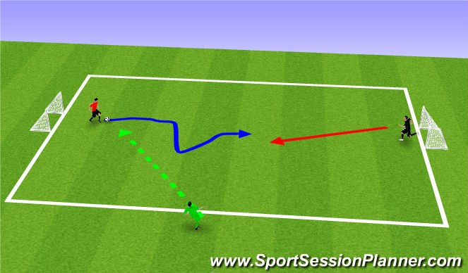
Coach=green
Attacker=Red
Defender= Black
Play 1v1 and 2v2
Person who is dribbling attacks the goal
Coach should focus soley on the defender and keeping them player in front of them.
Arms length away pressure the ball, but don't "lunge in"

